Red Ribbon Week: “Teasley Friends Don’t Let Friends Bully or do Drugs!”
Teasley Elementary School
October 26 – October 30, 2015
Red Ribbon Week is an alcohol, tobacco and other drug and violence prevention awareness campaign observed annually in October in the United States.

In honor of Red Ribbon Week and National Bullying Prevention Month, Teasley has an exciting week of activities planned for our students and staff to help us to remember to be happy and healthy. We want this week to be fun and educational, so we also encourage families to use this opportunity to discuss healthy lifestyle choices and safety with their children.
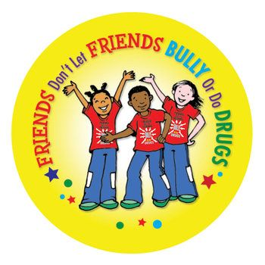
- Monday-“Red Ribbon Day”
Wear red and red ribbons today to show your
promise to live a healthy lifestyle.
(Ribbons will be given to students at school)
*Bring a Healthy Snack to school

- Tuesday- Teasley is United Against
Drugs And Bullying
Wear your Teasley Tiger spirit wear today to show
Teasley is united against drugs and bullying!
*Make a new Teasley Tiger Friend today!

- Wednesday- “Team up Against Drugs”
Wear your favorite team shirt.
*Stand up for someone if you see them being treated mean or unfair.

- Thursday- “Sock-It to Drugs and Bullying.”
Wear a pair of crazy or mismatched socks
*Bring a pair of new socks to help someone in need!

- Friday- “Look at what I can be if I stay Drug and Bully Free”.”
Bring $1 to support our PAWS foundation and you can wear an outfit to show a future job. (No costumes please) *Students sign the pledge that our school is no place for hate
Resources:
1. http://www.ncpc.org/topics/drug-abuse National Crime Prevention Council; "Tips, information, and publications aimed at preventing substance abuse"
2. http://www.timetotalk.org The Partnership for a Drug-Free America; "Time To Talk provides easy-to-use guides and tips to help you have ongoing conversations with your kids to keep them healthy and drug-free."

If you have any questions about Teasley’s celebration of Red Ribbon Week, contact your child’s teacher or counselor (Sherise Harris, grades K- 2; Corinna Oliver, grades 3-5).

